**Python and Anaconda**

**A guide to downloading and installing python and anaconda**

**Step 1: Download python**

You can download python from Python’s official website [*here*](https://www.python.org/).

You can choose to download the latest version/release but personally, I always advise going back two or three versions/releases as I have found them to be more stable and supported because they have gained popularity in different developer communities.

As you hover over “Downloads” you can select your Operating System, mine is “Windows”.

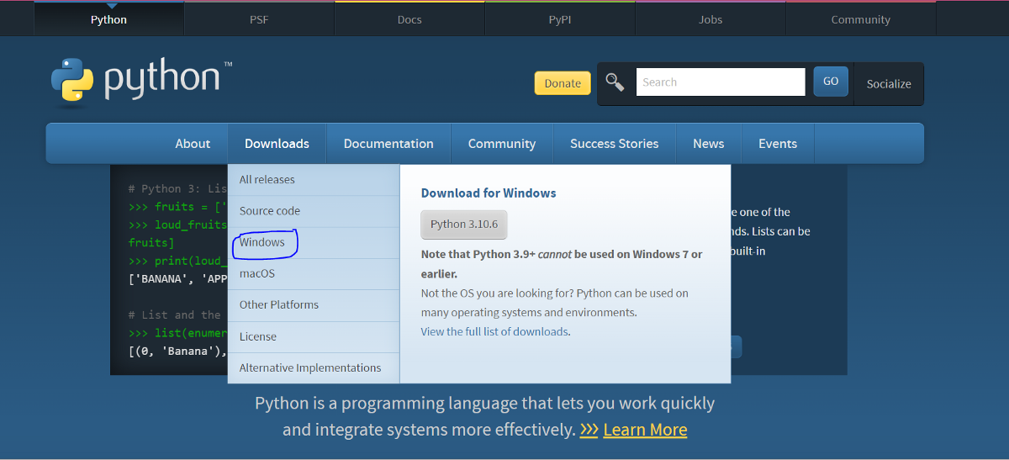

Instead of python 3.10.6, I opted for python 3.10.3 the 64-bit Windows installer.

**Step 2: Install Python**

When the download is complete as seen above you will be able to open it and start installing like below. Now if you don’t have any previous versions of python installed on your machine your options will differ from mine. You will get the option to install whereas I get the option to upgrade. However, before installing another important notice is you will get the option to “add python to path” please ensure that you tick that box and only then click “install now”.

Allow the installation to complete

**Step 3: Download Anaconda**

You can download Anaconda from Anaconda’s official website [*here*](https://anaconda.org/)

click on “Download Anaconda” as highlighted below and scroll down until you see the anaconda installers.

Select a suitable installer for your operating system, in my case it’s the Windows 64-bit Graphical installer. Anaconda is known to take a bit longer than python so do not fret, just wait it out and stay connected to the internet.

**Step 4: Install Anaconda**

Once the download is complete install Anaconda by double-clicking on the executable file seen above. the below screen will pop up then you may click “Next”

To continue with the installation you will need to agree to the terms and conditions, therefore, click “I agree”.

You will need to select who you want to install Anaconda for and as recommended select “just me” and click “Next

Select the installation location

One more time it’s important to add Anaconda to your path if you would like to use it globally on your machine. However, if you have python in your path it is not to your detriment should you choose to not add Anaconda cause leaving it out means that you will have to use Anaconda Command Prompt only in order to use Anaconda. My advice, add it to your path environment and then click “install” and allow the installation to proceed.

And once the installation is complete click “Finish”

Well done you are good to go with your basic software installations.

**How to run a notebook in Google colab**

Go to your google browser and search Google colab and click on “Welcome To Colaboratory – Google Research”

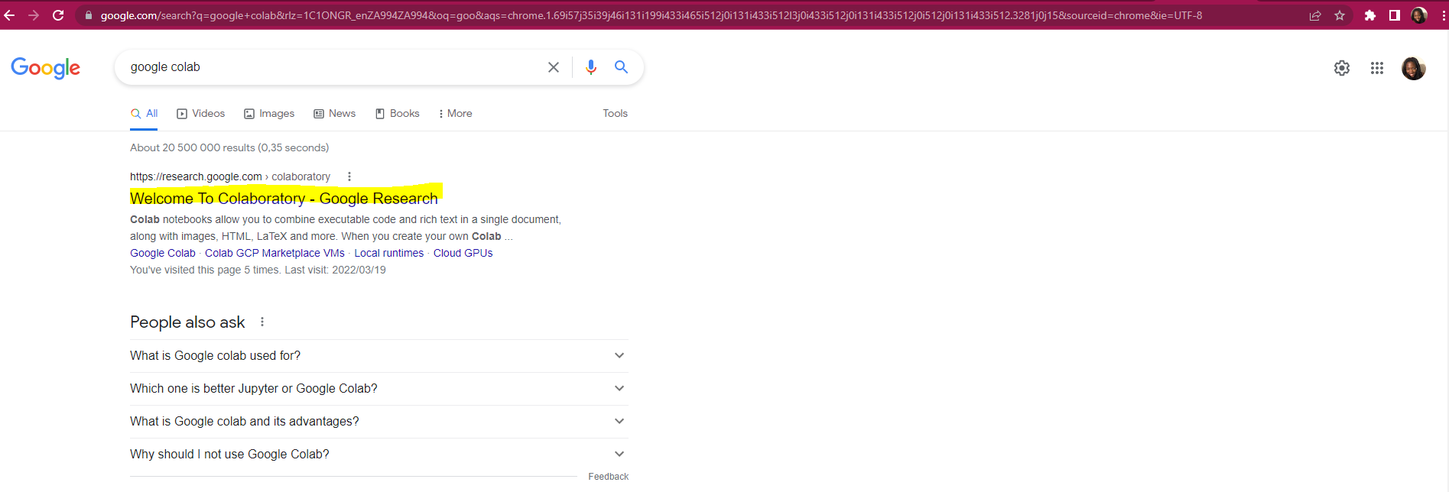

Once you have clicked “Welcome To Colaboratory – Google Research” the below window should open

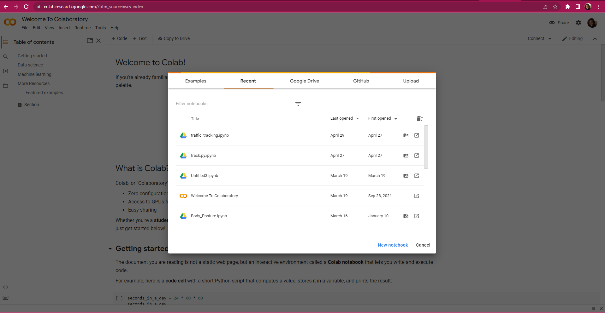

Now click on “Upload”

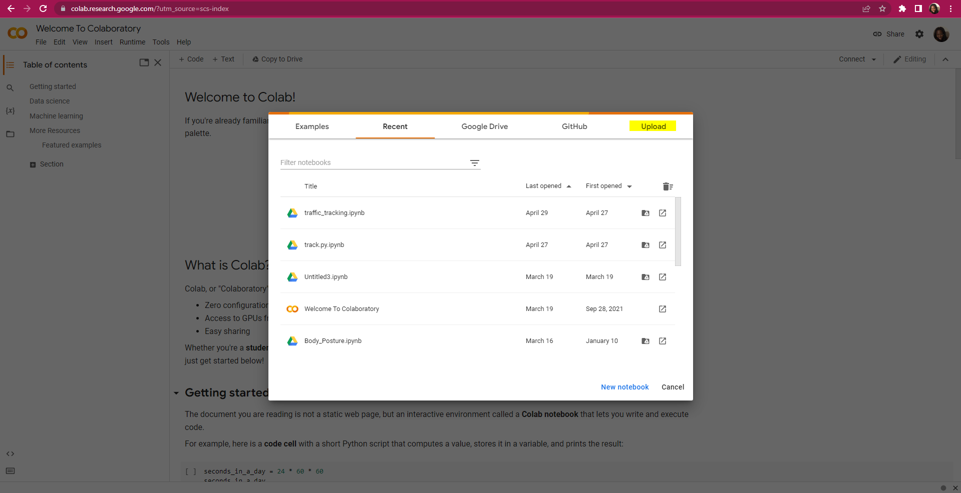

After clicking “Upload” the below window appears

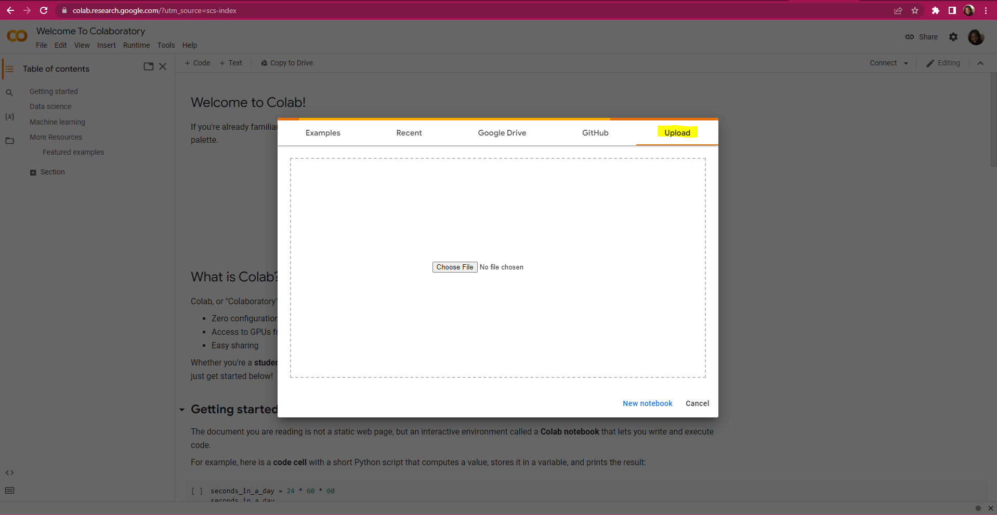

Then click “Choose File” , the below window will appear and the file “Wits Masterclass lecture 2” will be under your Downloads. Click on the file to select it

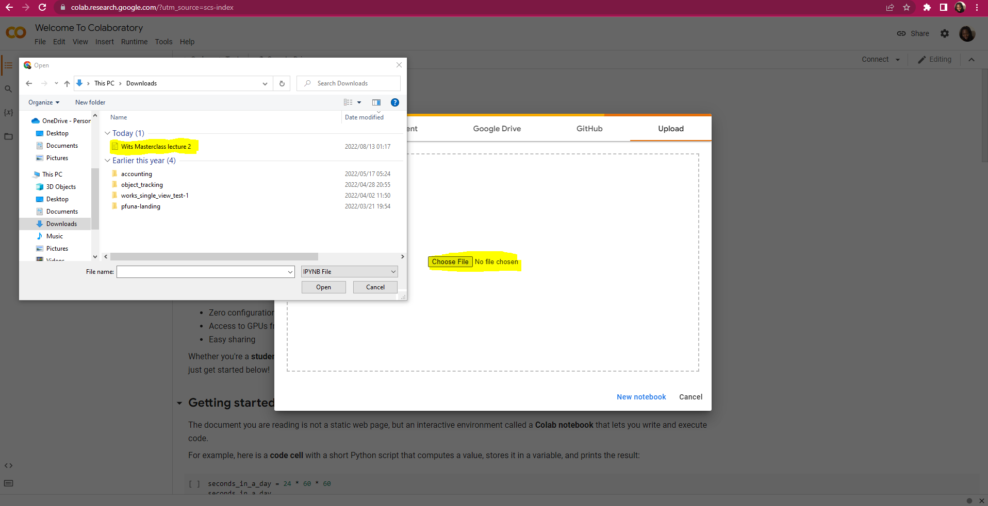

After selecting the file “Wits Masterclass lecture 2” ensure that it is selected as below and then click “Open”

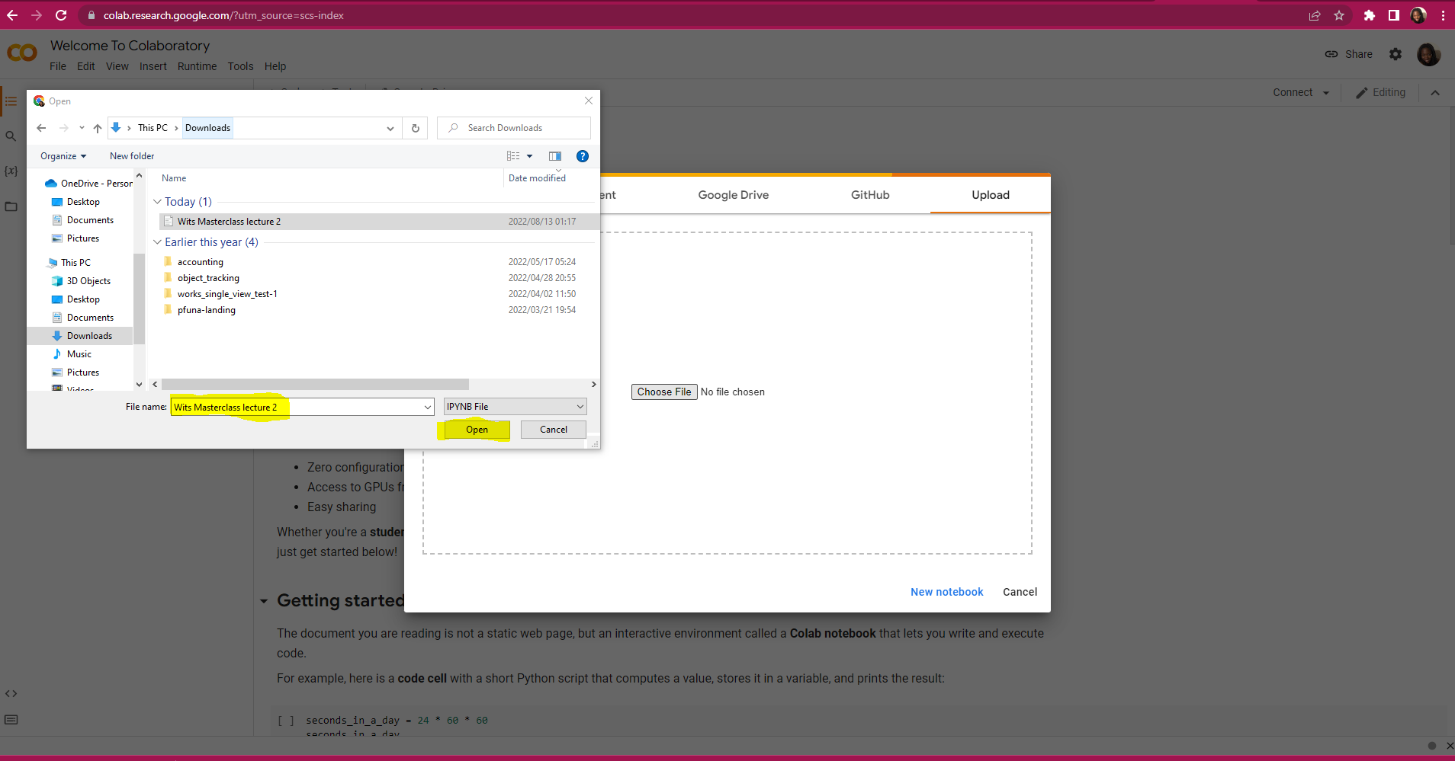

Once “open” has been clicked the notebook will open as follows.

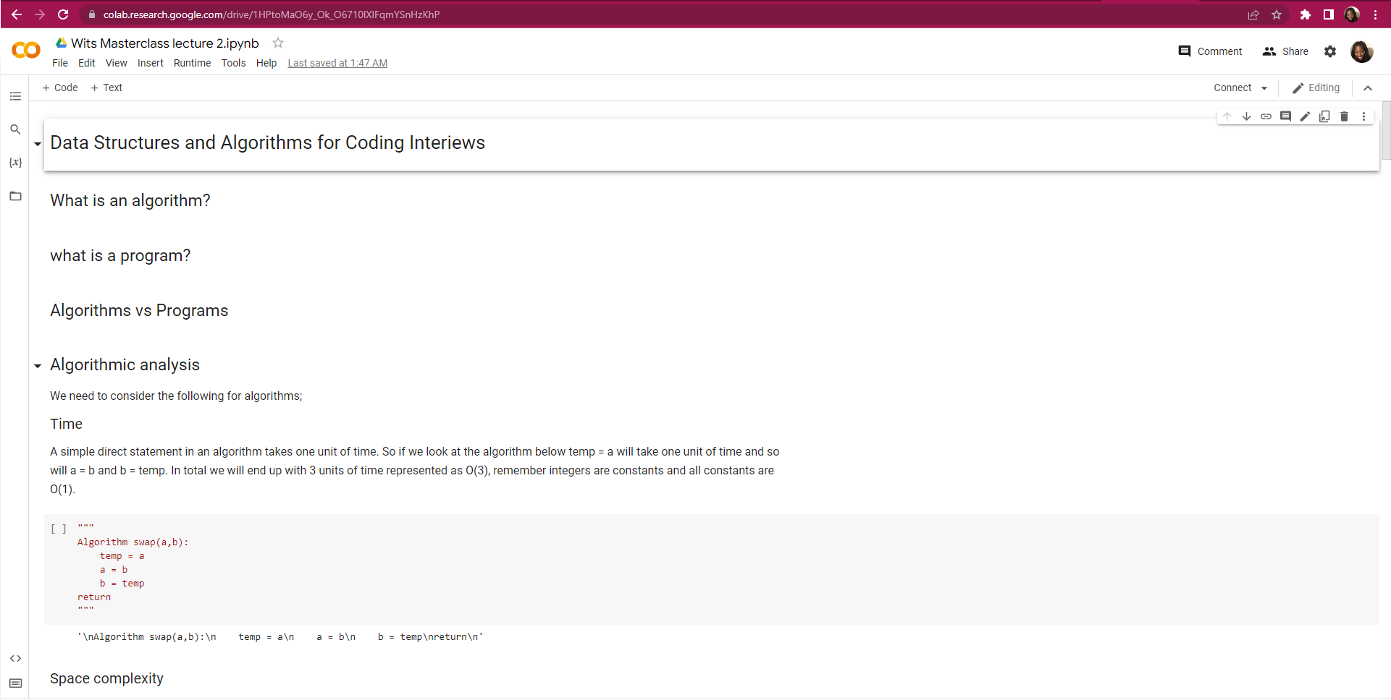

Well done! You have successfully opened a notebook in Google colab

**How to run a notebook in Jupyter Notebook**

Right click on your desktop and create a new folder by clicking “New” and then “Folder”

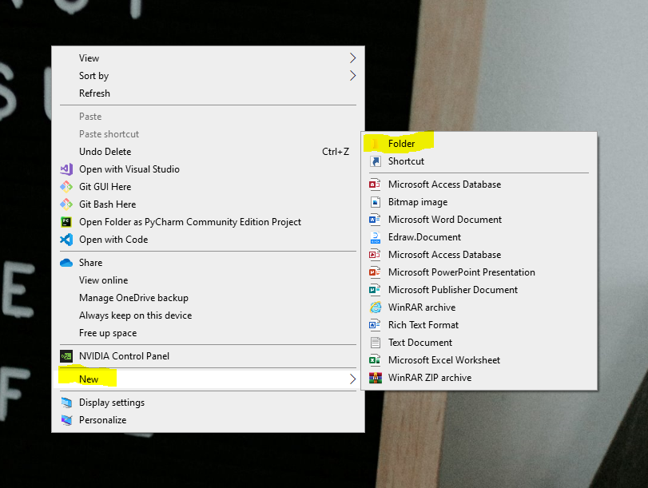

Name the folder “wits masterclass_’your name’” i.e “wits masterclass_gugu”. And then drag and drop the file “Wits masterclass lecture 2” into the newly created folder as seen below.

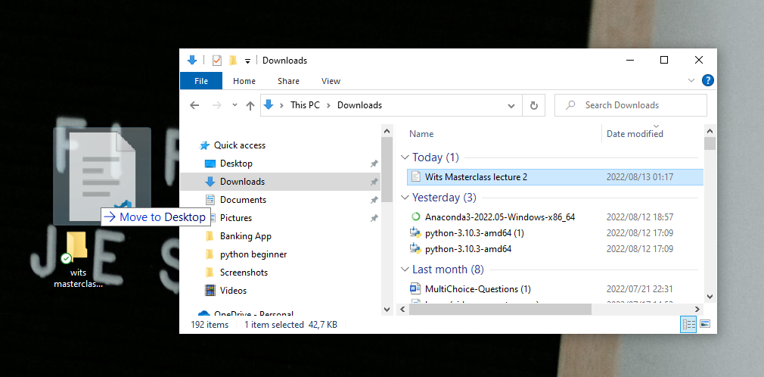

So quickly check that the file dropped correctly into the folder as seen below.

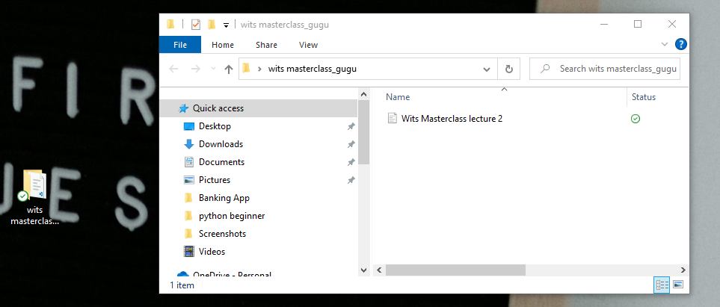

Now open your command prompt

cd into the folder and press enter.

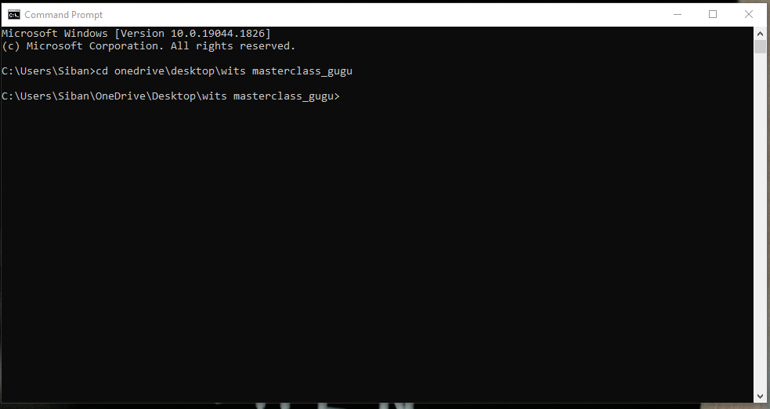

Type in the command jupyter notebook to open jupyter notebooks then press enter and patiently wait till jupyter notebooks opens in one of the browsers.

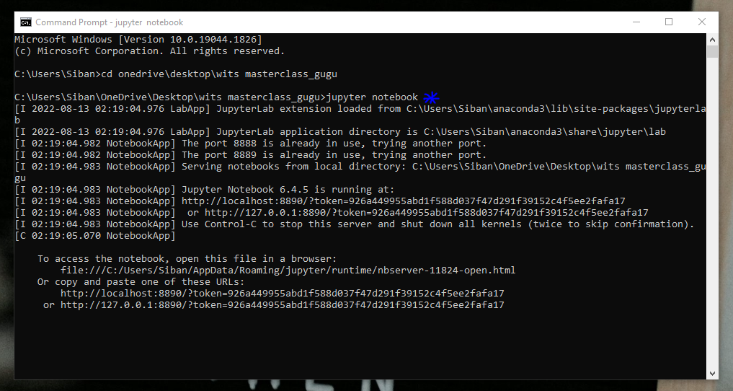

Once it has loaded successfully the screen below should appear.

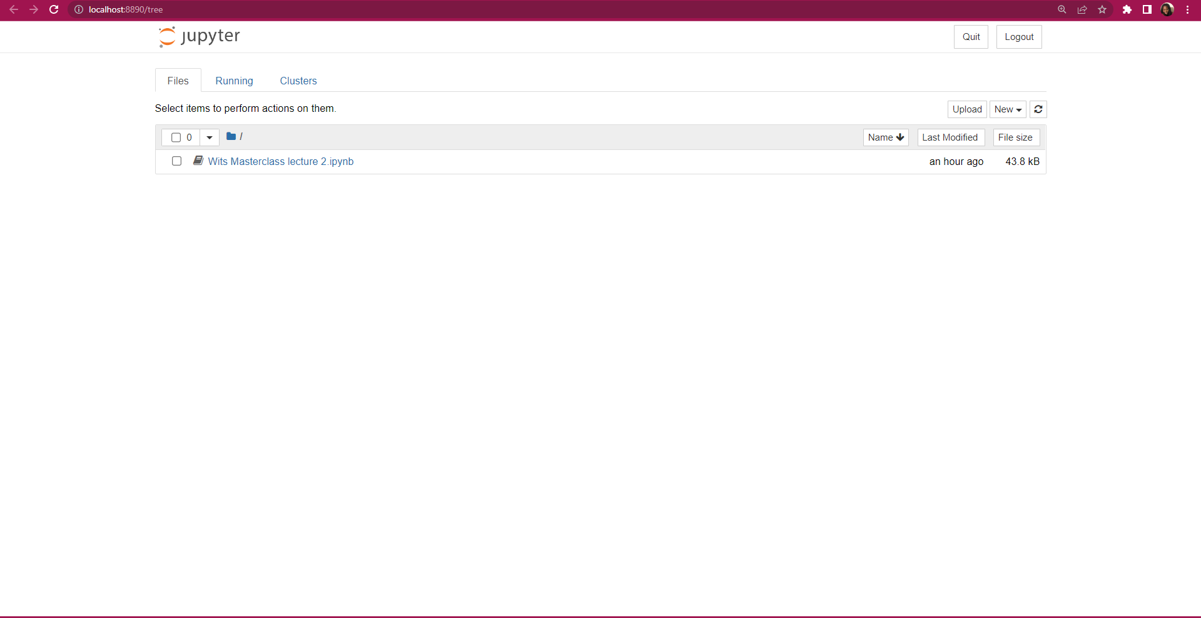

Now click on “Wits Masterclass lecture 2” to open the notebook.

Well done! You have successfully opened a notebook in Jupyter notebooks

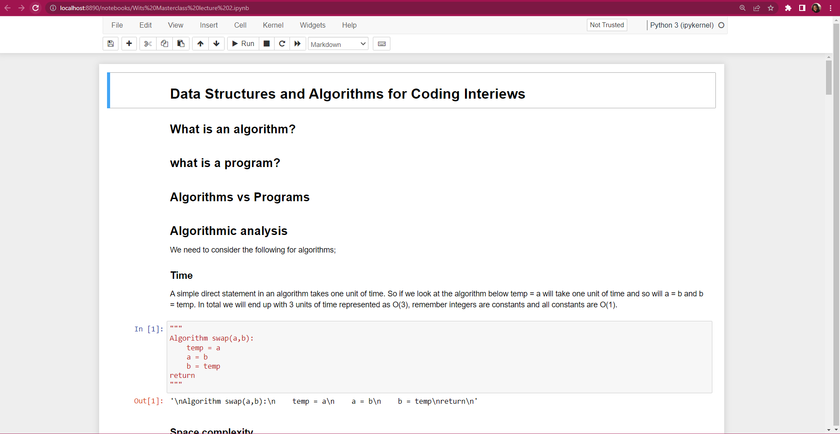

**Pro Tips**

* Familiarize yourself with documentation it will save you hours.
* Try projects as part of your learning.
* Read the errors and document resolutions the aim is not to squash errors the aim is to understand how you came about to have them and more importantly learn how to problem solve.

Thank you for reading